synthetic data

(https://github.com/intervene-EU-H2020/synthetic_data#quickstart-tutorial)

1. Instal Virtual Machine for singularity in it: <https://docs.sylabs.io/guides/3.0/user-guide/installation.html#install-on-windows-or-mac>

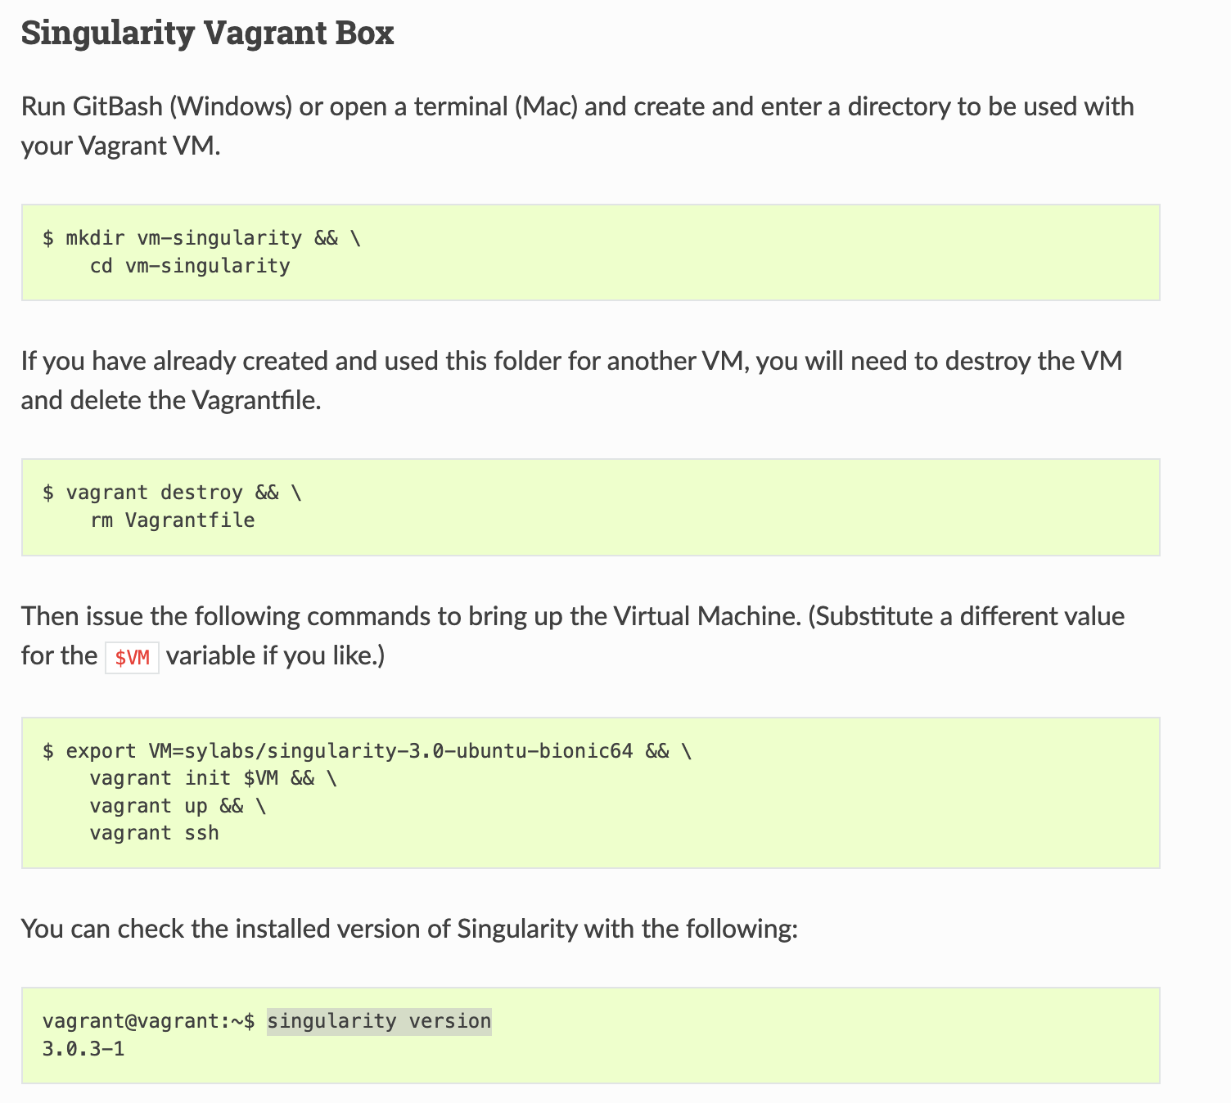

When you have configured vagrant, you can bring it up every time you need it with the command:

|  |
| --- |
| vagrant up && vagrant ssh |

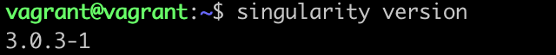

1. Install docker with synthetic-data:

|  |
| --- |
| singularity pull docker://sophiewharrie/intervene-synthetic-data |

